**Project Report: Keylogger with Encrypted Data Exfiltration**

**Project Title**

**Defender Project – Encrypted Keylogger with Decryption GUI (Ethical Use Only)**

**Objective**

To build a **proof-of-concept (PoC)** keylogger in Python that:

* Captures keystrokes using pynput
* Encrypts each keystroke using Fernet symmetric encryption
* Stores logs in an encrypted format
* Decrypts and views logs securely via a GUI built using **PyQt5**

**Tools & Technologies Used**

| **Tool / Library** | **Purpose** |
| --- | --- |
| Python | Core programming |
| pynput | Capturing keyboard input |
| cryptography (Fernet) | Encrypting/decrypting keystrokes |
| datetime | Timestamps for each keystroke |
| PyQt5 | GUI development |
| Tkinter *(optional)* | For basic GUI testing (initial phase) |

**How It Works**

**Keylogger Component (keylogger.py)**

* Captures each keystroke in real-time
* Encrypts it using a secure Fernet key
* Stores it line-by-line in log.txt as encrypted bytes

**Key Generation (key.key)**

* Key is generated once and reused for both logging and decryption
* Stored in key.key file in binary format

**GUI Decryption Tool (gui.py)**

* Built using PyQt5
* Allows user to:
  + Select both key.key and log.txt
  + Decrypt and view human-readable keystroke logs
  + Clear display window

**Features**

* ✅ Real-time keystroke logging
* ✅ AES-like secure encryption (via Fernet)
* ✅ Timestamped logs
* ✅ GUI-based log decryption and viewing
* ✅ File selection dialog and status messages
* ✅ Handles invalid data gracefully

**Folder Structure**

vbnet

CopyEdit

keylogger-project/

├── keylogger.py

├── gui.py

├── key.key

├── log.txt

├── decrypted_log.txt

└── README.md

**Ethical Disclaimer**

This project is built **strictly for educational and research purposes**.  
Running this code on any system without **explicit permission** is a **violation of ethical standards and possibly law**.

**Learning Outcome**

* Understanding of **keylogging techniques**
* Use of **symmetric encryption (Fernet)**
* GUI building using **PyQt5**
* Real-world security application awareness
* Ethical implications of monitoring tools

Output Screenshots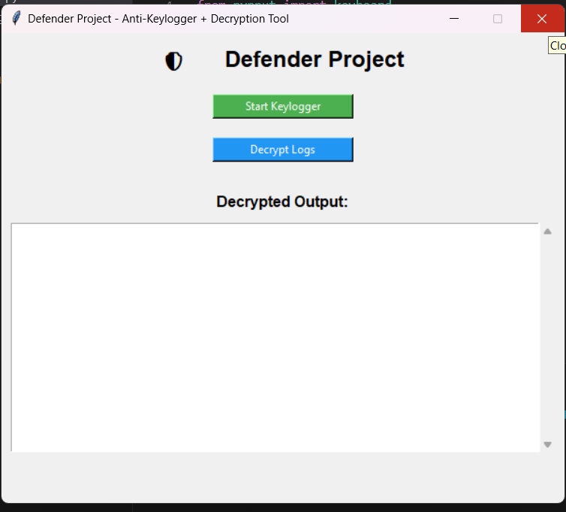

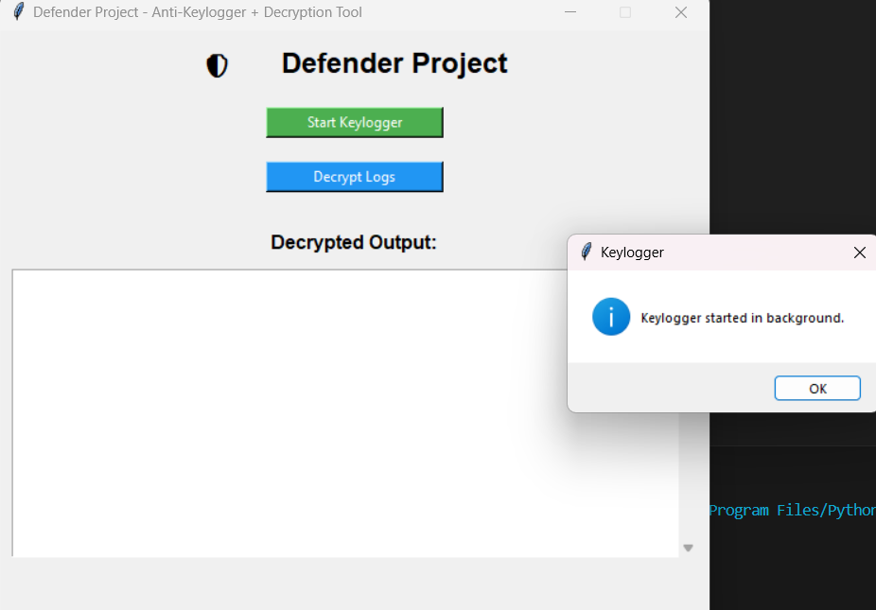

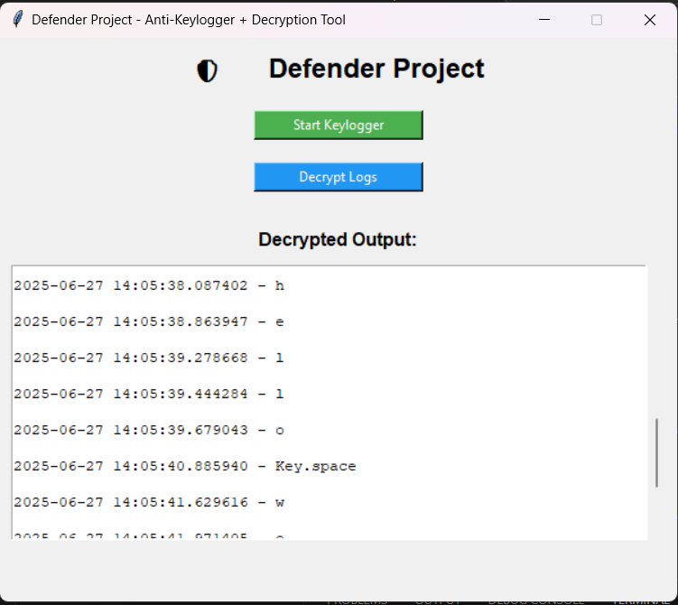

**Final Remarks**

The Defender Project demonstrates how sensitive data like keystrokes can be captured and encrypted, and also how proper GUI tools can be used to analyze such data securely and ethically. The project bridges **cybersecurity**, **Python development**, and **user interface design**.

Bottom of Form